

ISTANBUL TECHNICAL

**0**

**1**

UNIVERSITY

COMPUTER ENGINEERING

DIGITAL CIRCUITS LABORATORY

EXPERIMENT REPORT

EXPERIMENT NO: 8

EXPERIMENT NAME: SEQUENTIAL CIRCUIT DESIGN

EXPERIMENT DATE : 19.04.2013

GROUP NO: 6

STUDENTS WHO DID THE EXPERIMENT:

Student no Name Surname

**040100113 MUSTAFA UÇAR**

**040100117 TUĞRUL YATAĞAN**

040100124 EMRE GÖKREM

ASSISTANT NAME WHO ASSISTED THE EXPERIMENT: DENİZ DEMİRAY

1 )

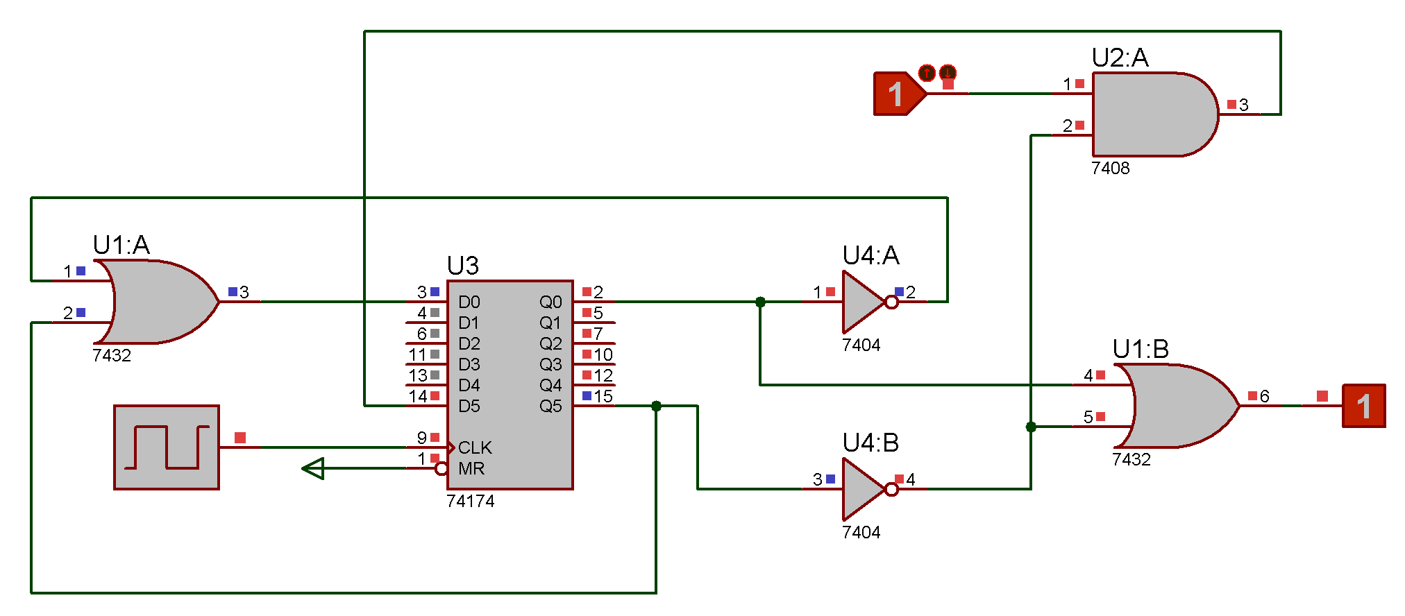

Q1+ = Q1’ + Q2

Q2+ = X.Q2’

Z = Q1 + Q2’

|  |
| --- |
| Q1+Q0+/Z |
| Q1Q0\X | 0 | 1 |
| A – 00 | 01,1 | 11,1 |
| B – 01 | 00,0 | 10,0 |
| C – 11 | 01,1 | 01,1 |
| D - 10 | 01,1 | 01,1 |

**2 )** 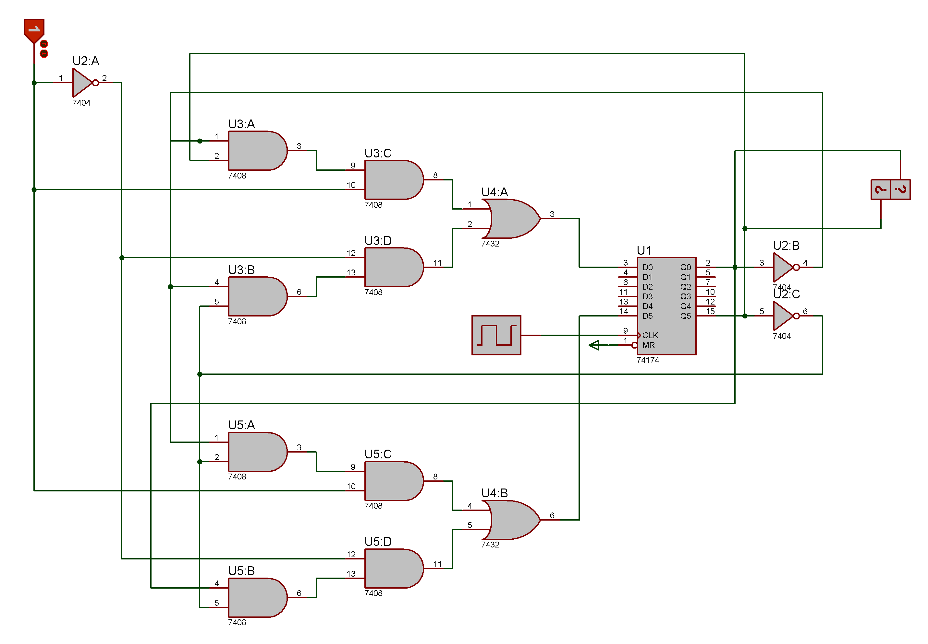

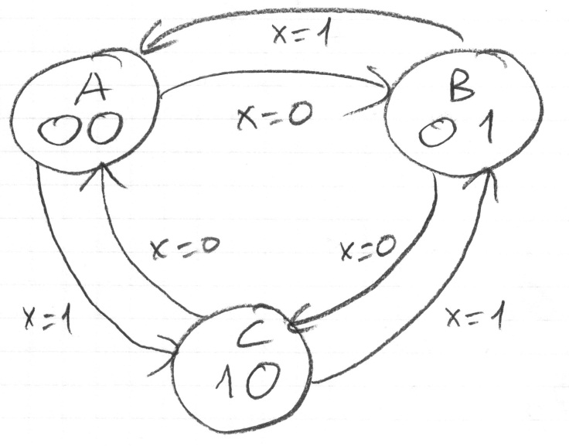

|  |
| --- |
| **S’Z** |
| **S\X** | **0** | **1** |
| **A** | B | C |
| **B** | C | A |
| **C** | A | B |

|  |
| --- |
| **Q1+ Q0+** |
| **Q1Q0\X** | **0** | **1** |
| **00** | 01 | 10 |
| **01** | 10 | 00 |
| **10** | 00 | 01 |

|  |
| --- |
| **D1** |
| **Q1Q0\X** | **0** | **1** |
| **00** | 0 | 1 |
| **01** | 1 | 0 |
| **10** | 0 | 0 |

|  |
| --- |
| **D0** |
| **Q1Q0\X** | **0** | **1** |
| **00** | 1 | 0 |
| **01** | 0 | 0 |
| **10** | 0 | 1 |

D1 = X’Q0Q1’ + XQ0’Q1’ = Q1’(XQ0’ + x’Q0)

D0 = X’Q0Q1’ + XQ0’Q1 = Q0’(XQ1 + X’Q1’)

**3 )**

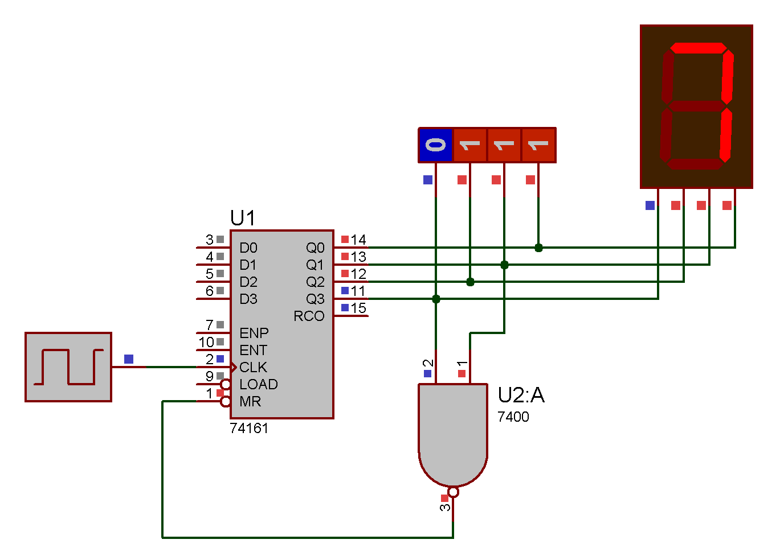

When 4th and 2nd bits are becomes 1, it means count is come to 1010. Because 1010 is smallest number that 4th and 2nd bits are 1. If both of them are 1, NAND gate will reset the counter.

**4 )**

